**Developing resilience and tolerance of crop resource use efficiency to climate change and air pollution (SUSCAP)**

Defra Project Code: **CH0215**

**Further development of the DO3SE crop model.**

This document describes the development of the DO3SE crop model that has taken place during the SUSCAP project. Three main aspects of the model have been developed: i. phenology; ii. O3 effect on photosynthesis and senescence and iii. upscaling from the leaf to the canopy.

The provision of data from the Spanish OTC experiment has been delayed due to restrictions in place during the covid-19 lockdown which reduced the number of variables that could be measured and have also delayed analysis of the experimental samples. However, to overcome this we have focussed efforts on evaluating the model against existing Spanish wheat data, which both ensures that the model framework is set up to utilise the experimental data once it becomes available and also helps to ensure the model outputs are in the right ball park for experimental observations.

We have also take this opportunity to consider further how the remotely sensed data, collated by our Romanian colleagues, can be used to evaluate the models. Focusing in the first instance on phenology given the importance of establishing the timing and length of the growing season across Europe, and in particular, the timing of anthesis to harvest, the growth stage most sensitive to damage by O3.

Finally, we are also working to establish systems by which we can compare the model outputs of the three models that will be used in SUSCAP which include DO3SE Crop but also LINTULLC2 and WOFOST. We show some initial comparisons between models of phenology estimates, which have been performed according to a phenology protocol that has been developed for this specific purpose and will also be used in the AgMIP-O3 exercise that this SUSCAP project also supports.

# Phenology

## Model Development

A key driver of O3 deposition to vegetated surfaces and stomatal O3 flux is seasonality (i.e. the timing of the physiologically active growth period); this will primarily depend on climate variables (especially temperature and photoperiod or daylength) determined by geographical location but will also be influenced by land-cover type and species. We propose to use the JULES-Crop phenology model (Joint UK Land Environment Simulator ( i.e. JULES-crop, (Osborne et al., 2015) within the DO3SE-Crop modelling framework.

The JULES-crop phenology model uses thermal time, estimated using an effective temperature (Teff, oCdays) calculated from wheat-specific cardinal temperatures of 0ºC, 20ºC and 30ºC respectively (Osborne et al., 2015). Teff describes the rate of crop development using accumulated thermal time intervals between the main wheat developmental stages (TTemr, TTveg, TTrep), the values are the model parameterisations suggested for wheat by (Osborne et al., 2015) (described in Table 1).

$$T_{eff}=\left\{\begin{aligned}0 for T<T_{b} \\ T-T_{b} for T_{b}≤T≤T_{0} \\ \left(T_{0}-T_{b}\right) \left(1-\frac{T-T_{0}}{T_{m}-T_{0}}\right) for T_{0}<T<T_{m} \\ 0 for T ≥T_{m}\end{aligned}\right\}$$

*Teff* is greatest and hence development is fastest at *T* = *To*. As temperature falls below or rises above *To* the rate of development linearly decreases until no development occurs when either T ≤ Tb or T ≥ *Tm*. For the sowing to emergence phase, *Teff* is not affected by *Tm* or *To* (i.e. *Teff* = *T* - *Tb*). This equation is a standard way of calculating effective temperature. An important difference to other

models is that JULES-crop model simulates a decline of *Teff* above the maximum temperature, whereas others keep *Teff* at the maximum value no matter how high temperatures get. Changing day lengths (*Photo*) can also slow progress towards flowering though sensitivity to this phenomenon varies with crop species. The JULES model provides a method for calculation of *Photo* but this is not used for spring wheat since this crop is not sensitivity to *Photo*.

The estimation of Teff allows estimates of crop development represented by the development index (DVI), with values that indicated the occurrence of four main developmental stages (-1 upon sowing, 0 on emergence, 1 at anthesis and 2 at maturity). This model does not estimate the double-ridge stage, and no effects of vernalisation or photoperiod are included. The rate of increase of DVI is calculated as follows, where TTemr is the thermal time between sowing and emergence, TTveg is the thermal time between emergence and flowering and TTrep is the thermal time between flowering and harvest

$$\frac{dDVI}{dt}=\left\{\begin{aligned}\frac{T_{eff}}{{TT}_{emr}} for-1≤DVI<0 \\ \left(\frac{T_{eff}}{{TT}_{veg}}\right) for 0≤DVI<1 \\ \frac{T_{eff}}{{TT}_{rep}} for 1≤DVI<2\end{aligned}\right\}$$

The growing season ends when DVI=2. Vernalisation, a cold temperature requirement for development in some crops, is not included in this model version.

Table 1. Wheat parameters used in phenology modelling (Osborne et al., 2015).

|  |  |  |
| --- | --- | --- |
| Parameter | Wheat | Notes |
| Tb | 0 | (Osborne et al., 2015) |
| To | 20 | (Osborne et al., 2015) |
| Tm | 30 | (Osborne et al., 2015) |
| TTemr (SGS) | 35 | (Osborne et al., 2015) |
| TTveg | 750 – 1000 (default 1000) | Calibrate according to regional data |
| TTrep (EGS) | 500 – 666 (default 667) | Calibrate according to regional data |
| Phyllochron intervals for tl,em period | 1.8 | (Porter, 1984) |
| Phyllochron intervals for tl,ma period | 3.5 | (Porter, 1984) |
| Flag leaf emergence, l, flag | DVI1 = 1 | (Osborne et al., 2015) |
| Tl,ep as a fraction of tl,ma | 0.67 | (Ewert & Porter, 2000) |
| Tl,se as a fraction of tl,ma | 0.33 | (Ewert & Porter, 2000) |

N.B. In Osborne et al. (2015) the values of TTveg and TTrep were allowed to vary spatially and determined such that, when used with the CRU-NCEP temperature climatology 1990–2000 and the (Sacks et al., 2010) sowing date, the crop reached DVID2.0 at the Sacks et al., (2010) harvesting dates, with x=TTveg/(TTveg+TTrep) with x equal to 0.6 for wheat.

The planting date of Sacks et al., (2010) and the derived maps of TTveg and TTrep are shown in Figure 1. Sacks et al., (2010) derived gridded planting dates from national- or district-level reported planting dates which are given in months rather than days. Therefore, there is little spatial or temporal variation in the sowing date which might well be expected due to variations in local climate and management practices. This could be improved upon for regional applications such as those across Europe and we will explore obtaining data on sowing dates from JRC within SUSCAP.

Figure 1. Global distribution planting date from Sacks et al., (2010), interpolated to NCEP grid, and the thermal time from emergence to flowering (TT_veg) and from flowering to harvest (TT_rep) for each crop type. See text for details of calculation.

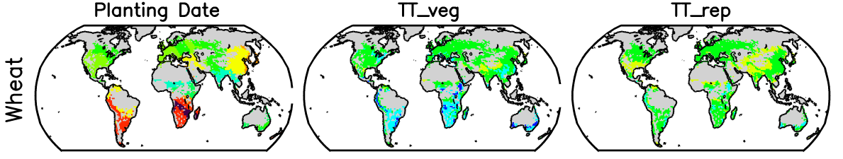



Once the crop development index (DVI) is calculated for wheat using the Jules phenology method, key development stages (and their associated Teff values) can used to define the canopy development period within which leaf populations (represented by a representative leaf of defined canopy layers) will develop and senesce, according to the model of Ewert & Porter (2000); see section 2. This can be represented by Figure 2.

Figure 2. Representation of the combination of leaf-level canopy layers based on a ‘representative’ leaf (using (Ewert & Porter, 2000 methods to estimate the leaf life-span) and whole canopy phenology development (using the JULES-Crop phenology model) used in the DO3SE-Crop model.



The calculation of the phyllochron, based on the change in daylight at emergence, is crucial to determine the life span of each ‘representative’ leaf (Tl).

Tl = Tts + Ttg

Ttg = 1.8*Tte; equivalent to tl, em in the (Ewert & Porter, 2000) module

Tts = 3.5*Tte; equivalent to tl, ma in the (Ewert & Porter, 2000) module

Where *Tte* is the phyllochron which is the interval between emergence of successive leaves; Tl is the life span of the leaf (oC Days); Ttg is the thermal time interval from emergence to maturity; Tts is the thermal time interval from initial maturity to senescence (oC Days).

The phyllochron is calculated as 1/y, where y is the rate of leaf emergence and is equal to 0.026 Δ + 0.0104; where Δ is the change in day length (in hours) from day n to day n+1, with day n being day of seedling emergence. The change of daylight at emergence (Δ) is calculated using the photoperiod which estimates the daylight hours based on the latitude.

For 5 canopy layers (and hence 5 representative leaves for each layer) we assume an equal (according to thermal time) 'spread’ of the life-span of our 5 ‘representative’ leaves across the crop development period so that they all complete their leaf life span by harvest. We can then estimate the thermal time interval between emergence of each successive leaf population (Teff_lpop) as

Teff_lpop = T,l - [( T,l * lay, n – (TTveg+TTrep)) / (lay, n - 1)]

An example is provided below for wheat growing in Nottingham, UK where TTveg + TTrep = 1491 oCdays; T,l = 435 oCdays; with 5 canopy layers each new leaf population would emerge 264 oCdays after the previous leaf population emergence.

Teff_lpop = 435 - [(435*5 - 1491) / 4] = 264 oC days

However, the top canopy layer leaf life span (layer 1) would be modelled as representative of the wheat flag leaf which would be assumed to emerge 200oC days before mid anthesis (i.e. DVI = 1).

## Model Evaluation

The AgMIP-O3 crop datasets were assessed to identify datasets suitable for evaluating the JULES phenological model, suitable datasets are described in Table 2 and have temperature data spanning the entire crop growth period as well as observations of wheat crop growth stages (i.e. sowing, emergence, anthesis, maturity). The Spanish Santa Olalla dataset is one that has been collected as part of this SUSCAP project by the Centre for Energy, Environmental and Technological Research (CIEMAT, Sanz et al., Unpublished), with measurements taken in the OTC Experimental Facility known as La Higueruela (MNCN-CSIC), located at 80 km from Madrid. All the AgMIP-O3 datasets are standardised (including gap filling) and checked for anomalies and data continuity.

Table 2. Summary of the AgMIP-O3 datasets selected for phenology model evaluation

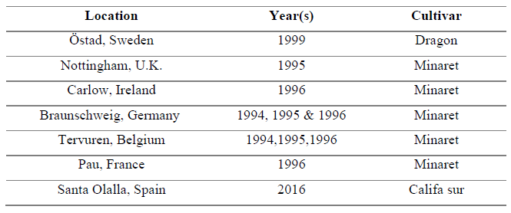

The observed dates or DOY (Day of Year) of sowing, emergence (Z09), double ridge (Z31), anthesis (Z60) and maturity (Z91), were then compared with the simulated DOYs of the three different phenology models (associated Zadoks scale given in brackets). To evaluate the performance of the models in simulating crop growth stages, the root mean square error (RMSE) was calculated following the AgMIP-O3 crop group phenological calibration protocol. As well as comparing the JULES phenology model described here, we also compared the three other models: the UNECE ‘LRTAP’ model (CLRTAP, 2017) and the ARCWHEAT1 model (with photoperiod and vernalization disabled) (Porter, 1984; Weir et al., 1984), this latter model will form the basis of the LINTULLC2 model that will also be used in the SUSCAP project (see Figure 3 and Table 3).

Figure 3. Accumulated thermal time (Teff (denoted as GDD); oCdays) and associated estimate of wheat developmental stages (sowing (square); emergence (circle); double ridge (triangle); anthesis (diamond); maturity (crossed square)) for each phenological model for Nottingham, UK 1995.

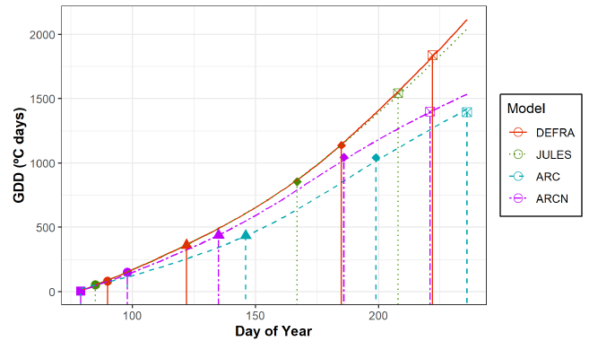

Table 3 Summary of the RMSE values for each model against observations of wheat phenology (cv. Minaret) for Nottingham, UK in 1995.

|  |  |  |  |
| --- | --- | --- | --- |
| Model | RMSEemergence | RMSEanthesis | RMSEharvest |
| LRTAP | 6.00 | 10.73 | 9.46 |
| JULES | 11.00 | 8.72 | 2.24 |
| LINTULLC2 | 5.63 | 10.81 | 8.33 |

The most accurate model in simulating the DOY of emergence was the ARCWHEAT1, while the JULES-crop was better in estimating the DOY of anthesis and maturity.

A comparison of the JULES-Crop model against all AgMIP-O3 datasets is shown in Table 4. TTANTH and GFDUR describe the parameterisation of TTveg and TTrep that gave the best RMSE value for that site and year showing the variability in these parameters. Further work is needed to identify the default parameterisation than can be used reliable for wheat across Europe. Access to remote sensed LAI data is likely to provide useful for this exercise.

Generally, across all datasets, the JULES-crop was found to be the most accurate model in estimating the occurrence of anthesis and maturity with an RSME of 8.41 and 4.17 days respectively, by comparison, RMSE values for the LRTAP model were 8.93 and 10.48 days, and for the ARCWHEAT1 model 20.32 and 16.45 days (data not shown). Nonetheless, the DEFRA and ARCWHEAT1 models were more accurate in simulating emergence with an RSME 4.01 and 4.67 days respectively, but 7.41 days for JULES-crop (data not shown). ARCWHEAT1 was better in estimating the double-ridge with an RSME of 7.29 days compared to 15.19 days of DEFRA.

Table 4. Summary of the JULES-Crop model best selected parameters and corresponding RMSE for anthesis (RMSEANT) and maturity (RMSEMAT).

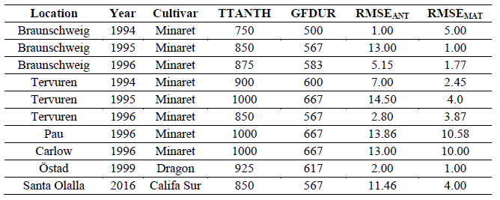

Finally, we have started to investigate the possibility of using remotely sensed data of LAI to provide additional calibration and evaluation datasets.

LAI data for winter wheat were estimated based on Schiffman’s formula (Basson et al., 2007) and processed by George Boldeanu, Junior/Young Researcher at Remote Sensing and GIS Laboratory of National Meteorological Administration in Romania. Landsat 8 OLI satellite images from 2015 and 2018 were used to obtain the LAI data by using Google Earth Engine APIs and a code editor, used in full compliance with the terms and conditions imposed by Google Inc. on usage rights.

A total of 208 files containing LAI data in GeoTIFF format with a World Geodetic Survey 1984 (WGS84/EPSG:4326) projection were provided, together with 334 polygons comprising the periods from 01/11//2014 to 30/06/2015 and 01/11/2017 to 30/06/2018. These polygons were obtained based on ground validation using the Land Use/Cover Area frame statistical Survey (LUCAS) dataset which provided detailed features for land cover/use around Europe (Karydas, et al., 2015), that allowed areas that would most likely only have wheat growing to be defined. The data comprised information from six European countries, summarised in Table 5 with the corresponding Landsat 8 scene path and row.

Table 5. Summary of the LAI Landstat 8 datasets.

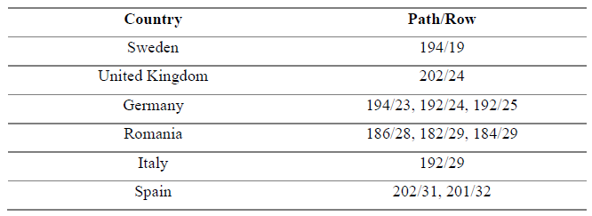

The GeoTIFF files were imported into raster format and processed using the ArcGIS 2.3.3. A geoprocessing workflow was built using ArcGIS ModelBuilder visual programming language in order to carry out the analysis of all the files through an iteration tool (Figure 4). Initially, pixels containing no data values were removed from each file to prevent errors during the model sequence. Afterwards, the polygons in shapefile format were used to calculate the mean LAI value within each feature and then converted into point features to sample and extract the calculated values into a table which was finally exported as MS-EXCEL worksheet file.

Figure 4. Model builder geoprocessing workflow. Input variables (in blue) and output variables (in green) are enclosed in circles and the main processes are enclosed in rectangles (in yellow) with arrows indicating the flow direction.

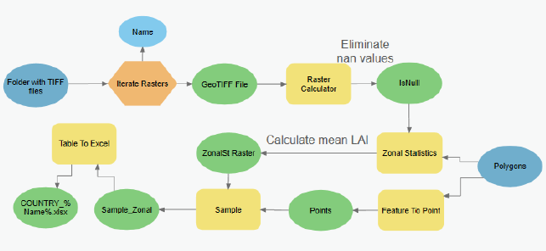

The output data from the ModelBuilder was finally analysed using RStudio (Version 1.2.5001) to observe any patterns that could be linked to the developmental stages simulated by the wheat phenological models.

LAI profiles were produced for each location and year (i.e. 2015 and 2018), from which two evident profiles were observed, a high-peak and a steep-slope profile. The first profile showed a low and generally constant LAI value during the earlier DOYs, after which it abruptly increased until a maximum peak was reached before starting to decrease. The second profile was similar at the start and until the maximum LAI value was reached; however, no decrease in the LAI values occurred after reaching its maximum probably because the period where a decrease might have been expected to occur was not available. The LAI profiles for each year are displayed over the corresponding locations in Figure 5 and Figure 6.

Figure 5. Map of Europe showing the LAI profiles at each location for the year 2015. Profiles, with time (in months) on the x-axis and LAI (m2/m2) on the y-axis, are placed over the corresponding path and row of the Landsat scene from which the LAI values were extracted. Countries with LAI data are highlighted in dark blue.

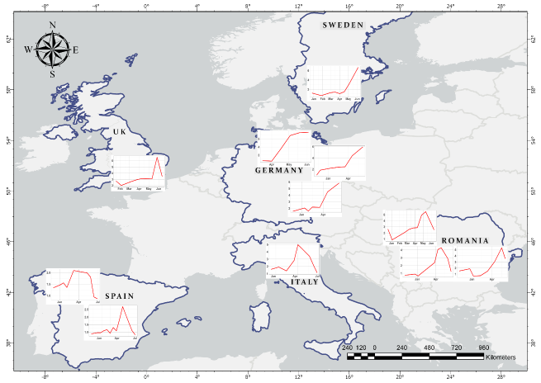

Figure 6. Map of Europe showing the LAI profiles at each location for the year 2018. Profiles, with time (in months) on the x-axis and LAI (m2/m2) on the y-axis, are placed over the corresponding path and row of the Landsat scene from which the LAI values were extracted. Countries with LAI data are highlighted in dark blue.

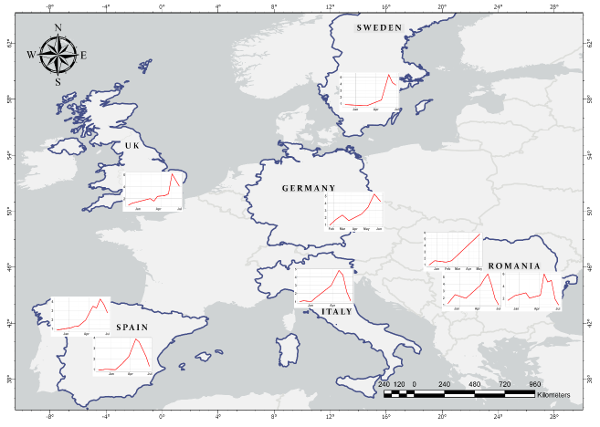

For the year 2015, the United Kingdom, Spain, Romania and Italy showed a high-peak profile, reaching a mean maximum LAI value of 6.56, 2.69, 5.49 and 4.98 (m2/m2) respectively. In contrast, Germany and Sweden showed a steep-slope pattern with a mean maximum LAI value of 5.95 and 6.68 (m2/m2) respectively. Overall, Spain presented the lower LAI values, with a rather flattened profile when compared with the rest of the locations. The minimum LAI ranged between 0.66 and 2.27 m2/m2.

Those datasets with the high-peak profile can be assumed to have gone through a full SGS to EGS cycle, as they are similar to the LAI profiles obtained by Porter, (1984). Such remotely sensed LAI profiles could provide an indication of development, as canopy growth and senescence are related in wheat development (Ewert & Pleijel, 1999) and hence to evaluate crop phenology models. Relationships between LAI profiles and phenology have been described previously, particularly for double-ridge and anthesis. Lower LAI values have been observed during the earlier stages of plant development (Z31) and higher LAI values when more advanced plant development stages (Z51–Z60) were reached (Siegmann & Jarmer, 2015). Maximum LAI has been reported to occur with some variability around the time of anthesis. (Maas, 1993) attributed this variability phenological stage with remotely sensed maximum LAI values since the later represent photosynthetically active plant area receptive to the reflectance of any green plant component in the wheat canopy, such as stems and heads, that remain green after all the leaves have senesced . This would result in maximum LAI values at the time of heading (Z50) and LAI persistence after anthesis. Nevertheless, since for wheat canopy all new green area has been produced at anthesis, after which LAI begins to decrease reaching zero at the end of the grain filling stage (Lawless et al., 2005), maximum LAI values may be used to at least support evaluation of crop phenology models. This will be explored further with our SUSCAP remote sensing (Romania) and crop modelling (Germany, Italy) colleagues.

# O3 flux module for photosynthesis and leaf senescence

The stomatal conductance (gsto) component of the DO3SE model has been developed to use a coupled photosynthesis- stomatal conductance module (An-gsto). The objective of the coupled An-gsto model is to provide a consistent estimate of the exchange of CO2 (driven by supply and demand of CO2 for photosynthesis and the products of photosynthesis); water vapour (controlled by gsto) and stomatal ozone uptake (fO3,s). The Anet-gsto model consists of a combination of two separate models i. the empirical An-gsto model that estimates gsto (Leuning, 1990) and ii. the mechanistic and biochemical Farquhar model (Farquhar et al., 1980) that estimates net carbon assimilation or net photosynthesis (An).

The An model assumes that photosynthesis is limited, according to prevailing environmental conditions, by 3 different mechanisms: i. rubisco activity (Ac); ii. the regeneration of ribulose-1,5-bisphosphate (RuBP) which is limited by the rate of electron transport (Aj) or iii. the inadequate rate of transport of photosynthetic products (most commonly triose phosphate utilization) (Ap). These influences on An are calculated by determination of the smaller of these theoretical CO2 assimilation rates less the rate of dark respiration (Rd) (Farquhar et al., 1980) as described in eq.

$$A_{n}=\min\left(A_{c},A_{j}, A_{p}\right)-R_{d}$$

We have developed the DO3SE-Crop model to incorporate the effects of O3 on the estimation of Ac (i.e. the O3 effect on the Rubisco limited rate of photosynthesis) using the methods of Ewert & Porter (2000) as described below. These methods assume that Ac decreases (i) immediately at high O3 fluxes (fO3,s(d)) and (ii) with leaf senescence which is enhanced as a function of cumulative O3 uptake (fLS)

Where Vcmax is the maximum carboxylation capacity, Ci and Oi are the intercellular CO2 and O2 concentrations; KC and KO are the Rubisco Michaelis-Menten constants for CO2 and O2; Г* is the CO2 compensation point in the absence of respiration.

### Calculating leaf-life span duration

The leaf-life span (T,l) is defined as the period between leaf emergence and complete senescence and is modelled as described previously in section 1. Tl comprises the thermal time intervals tl,em and tl,ma such that

$$T,l=tl,em+tl,ma$$

Where tl,ma comprises the thermal time during which the leaf is fully expanded (tl,ep) and the thermal time during which the leaf is senescing (tl,se).

$$tl,ma=tl,ep+tl,se$$

The calculation of these time intervals is achieved using the thermal phyllochron as described in section 1, based on the change in daylight at seedling emergence.

### Short-term ozone response

Plants exposed to high O3 flux over the short-term have shown impacts on Vcmax, whereas at low O3 fluxes plants can recover fully *via* a repair system and through detoxification without impacting Vcmax. These effects are simulated by assuming a linear relationships between stomatal O3 flux and Ac which is represented by factor fO3,s calculated for every hour.

fO3,s (h) = 1 ; for fO3st ≤ γ1 / γ2

fO3,s (h)= 1+ γ1- γ2* fO3st ; for γ1/γ2 < fO3st<(1+γ1)/γ 2

fO3,s (h) = 0 ; for fO3st ≥ (1+ γ1)/ γ 2

where fO3st is instantaneous O3 uptake and γ1 (0.06) and γ2 (0.0045 nmol/m2/s) are empirically determined coefficients representing the short-term damage coefficient (defined in Ewert & Porter, 2000). γ1 accounts for the fact that low O3 concentrations are detoxified without direct effects on the photosynthetic systems and γ2 describes the decrease in Ac per unit of fO3st. fO3st is calculated using the DO3SE-Crop model taking into account O3 deposition to the external leaf surface as well as the O3 taken up via the stomates. Ewert & Porter (2000) do not assume repair of O3 damage during daylight and therefore calculate the O3-induced reduction on Ac considering the damage caused by O3 during the previous hour during the daylight period (i.e. there is a cumulative effect of O3 flux on VC max over the course of a day). Applying the equations below will provide an estimate of fO3,s at the end of the day.

$fO3,s\left(d\right)=fO3,s\left(h\right)fO3,s(h-1)$; for *h* = 2….n (for daylight hours)

$fO3,s\left(d\right)=fO3,s\left(h\right)rO3,s$; for h=1

Ewert & Porter (2000) assume that O3 repair (i.e. repair of the final, end of day, value of fO3,s(d) occurs during the night but that incomplete recovery from O3 damage occurring during the previous day (rO3,s) can occur and influence the calculation of the O3 effects on Ac of the following day. The extent to which incomplete recovery occurs is dependent upon leaf age according to.

$$rO3,s=fO3,s\left(d-1\right)+\left(1-fO3,s\left(d-1\right)\right).fLA$$

Where fO3,s(d-1) is the fO3,s(d) at the end of the previous days daylight period (i.e. equivalent to h=1 of the current day) and fLA accounts for leaf age and is calculated over the life-span of the leaf, Tl. This allows young leaves to fully recover from O3 damage but for recovery to decline with age.

$fLA=1$; for al ≤ tl,em

$flA=1-\frac{al-tl,em}{tl,ma}$; for tl,em < al < Tl

$fLA=0$; for al ≥ Tl

Where al is the age of the leaf in oCdays. In mature leaves the repair capacity decreases linearly with the age of the mature leaf and falls to zero when the leaf is dead. Figure 7 shows these wheat leaf life span thermal time components in relation to phyllochron intervals as described in Section 1.

Figure 7. Wheat leaf life span thermal time components in relation to the wheat phyllochron.

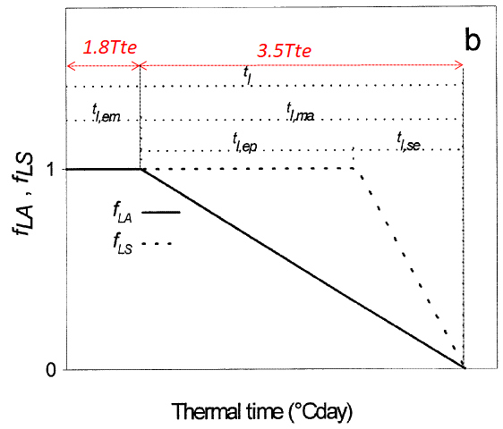

The effect of these O3 effect equations can be seen in Figure 8 & 9 using data for Spanish wheat.

The results of applying the An-gsto component of the DO3SE-Crop model with the incorporation of the (Ewert & Porter, 2000) O3 effect on photosynthesis module are described in Figure 8 for Spanish wheat; these plots show both the daily and seasonal variation in both the An and gsto variables.

Figure 8. Net photosynthesis (An; µmol CO2 /m2/s) and gsto (mmol O3/m2/s) for Spanish wheat on application of the An-gsto DO3SE Crop module.

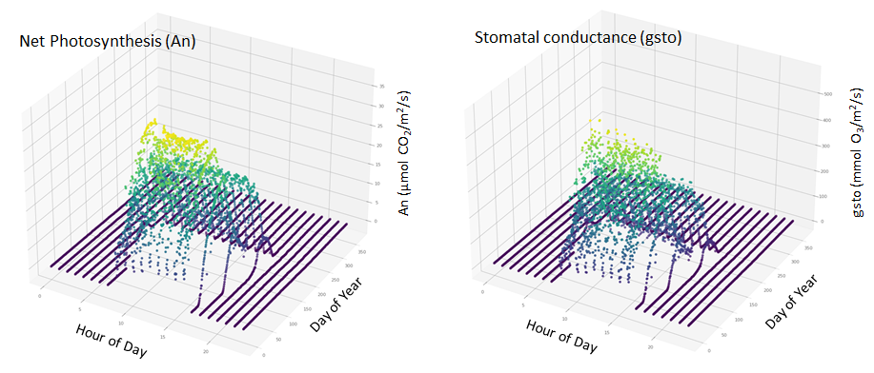

Figure 9. Seasonal profile of (i) O3-induced reduction on Ac (fO3s,(d)); (ii) incomplete recovery of O3 induced damage from previous day (rO3,s) and leaf age in relation to O3 recovery status (fLA) for Spanish wheat.

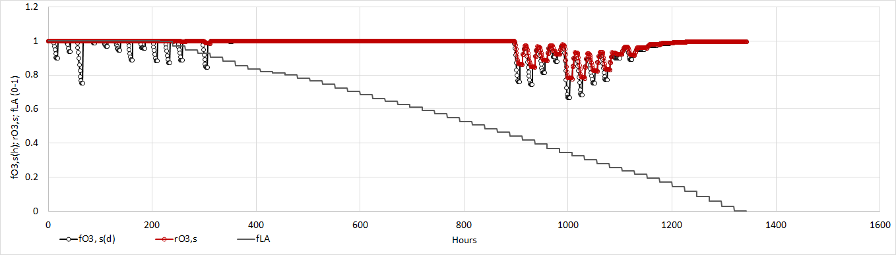

Figure 9 shows that O3 damage will occur during the early part of the season (which will have an instantaneous impact on photosynthesis; as denoted by the reductions in fO3,s(d)) but that Ac is able to recover overnight. However, later in the season, as the leaf ages, the overnight recovery is reduced such that high O3 fluxes during the previous will lead to damage that is felt into the following day.

## Long -term ozone response

Long-term accumulation of low doses of O3 lead to degradation of the rubisco enzyme and triggers early senescence of mature leaves. Ewert & Porter (2000) simulate this effect with a linear relationship between the life-span of a mature leaf (tl,ma) and accumulated O3 dose of the leaf (POD,l).

$$tl,ma=\left(tl,ep+tl,se\right).fO3,l$$

Since tl,se changes with tl,ma (following tl,se=0.33 tl,ma; Porter, 1984) both the signal for the onset of senescence and the rate of senescence are affected due to O3 dose represented by the factor fO3,l which is calculated as a function of accumulated O3 uptake (POD) and an empirically determined coefficient (γ3; 0.5 (μmol/m2)-1; O3 long term damage co-efficient).

$$fO3,l=1-γ3\int_{0}^{t-t1}{POD dt}$$

The coefficient γ3 describes the reduction in the life-time of a mature leaf per unit accumulated O3 uptake.

Finally, the factor that accounts for the effect of leaf senescence on Ac is calculated as

$fLS=1$; for al ≤ tl,em + tl,ep

$fLS=1-\frac{al-tl,em-tl,ep}{\frac{tl,ma}{fO3,l}-tl,ep}$; for tl,em + tl,ep < al < Tl

$fLS=0$; for al ≥ Tl

Where age of leaf (°Cday); Tl is the leaf life span; tl,ma is the thermal time interval of a mature leaf; tl,se is the thermal time interval of a senescing leaf; tl,ep is the thermal time interval of an expanding leaf and fO3,l is the factor which accounts for long term O3 impact on Vcmax.

The effect of applying these formulations to Spanish wheat data would see the leaf start to senesce 3 days earlier (moving from day 151 to 148 (see Figure 10).

Figure 10. The influence of O3 on senescence for Spanish wheat where fLS is the fraction by which VCmax will be modified under O3 compared to under O3 free conditions (fLS (no ozone)).

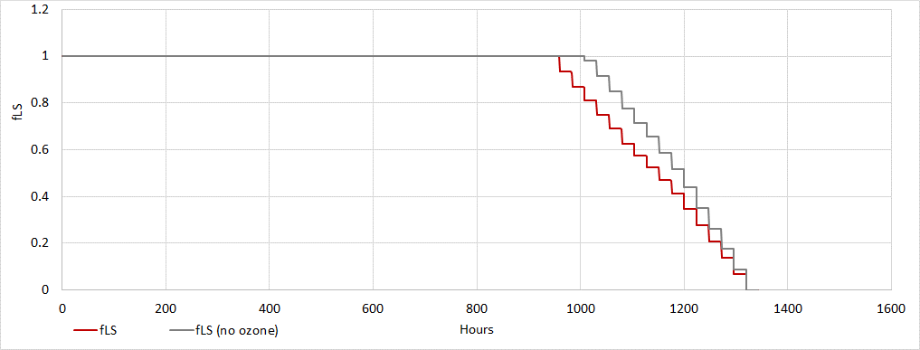

## Upscaling

The next steps in the development and testing of the model will be to implement the upscaling procedures. These will include i. new algorithms to more accurately describe the distribution of light throughout the canopy layers; ii. the implementation of existing resistance algorithms that calculate O3 deposition (and hence O3 profile down through the canopy) by canopy layer and; (iii) algorithms that account for the variation in leaf nitrogen throughout the canopy. By accumulating the various gsto and An variables within each canopy layer by sun lit and shaded leaf area indices an estimate of whole canopy gsto and An can be derived. This allows the effect of O3 on canopy C assimilation to be assessed, and through the inclusion of JULES Crop C allocation algorithms the O3 effect on biomass and yield can be determined. These various algorithms are in the process of being implemented and will soon be tested against the Spanish wheat dataset provided by our Spanish colleagues in Madrid.

## References

Basson, G., Hawk, A., Lue, E., Ottman, D., Schiffman, B., Ghosh, M., … Skiles, J. (2007). Estimation of Leaf Area Index (LAI) Through the Acquisition of Ground Truth Data in Yosemite National Park. In *AGU Fall Meeting* (p. Abstracts 43, B43C-1454).

CLRTAP. (2017). Mapping Critical Levels for Vegetation, Chapter III. *Manual on Methodologies and Criteria for Modelling and Mapping Critical Loads and Levels and Air Pollution Effects, Risks and Trends.*, *2017*(April), 1–66. Retrieved from https://www.umweltbundesamt.de/sites/default/files/medien/4292/dokumente/ch3-mapman-2017-10.pdf

Ewert, F., & Pleijel, H. (1999). Phenological development, leaf emergence, tillering and leaf area index, and duration of spring wheat across Europe in response to CO2 and ozone. *European Journal of Agronomy*, *10*(3–4), 171–184. https://doi.org/10.1016/S1161-0301(99)00008-8

Ewert, F., & Porter, J. R. (2000). Ozone effects on wheat in relation to CO2: Modelling short-term and long-term responses of leaf photosynthesis and leaf duration. *Global Change Biology*, *6*(7), 735–750. https://doi.org/10.1046/j.1365-2486.2000.00351.x

Farquhar, G.D., von Caemmerer, S., Berry, J. A. (1980). A biochemical model of photosynthetic CO2 assimilation in leaves of C3 species. *Planta*, *149*, 78–90.

Karydas, C. G., Gitas, I. Z., Kuntz, S., & Minakou, C. (2015). Use of LUCAS LC point database for validating country-scale land cover maps. *Remote Sensing*, *7*(5), 5012–5041. https://doi.org/10.3390/rs70505012

Lawless, C., Semenov, M., & Jamieson, P. D. (2005). A wheat canopy model linking leaf area and phenology. *European Journal of Agronomy*, *22*, 19–32. https://doi.org/10.1016/j.eja.2003.11.004

Maas, S. J. (1993). Within‐Season Calibration of Modeled Wheat Growth Using Remote Sensing and Field Sampling. *Agronomy Journal*, *85*(3), 669–672.

Osborne, T., Gornall, J., Hooker, J., Williams, K., Wiltshire, A., Betts, R., & Wheeler, T. (2015). JULES-crop: A parametrisation of crops in the Joint UK Land Environment Simulator. *Geoscientific Model Development*, *8*(4), 1139–1155. https://doi.org/10.5194/gmd-8-1139-2015

Porter, J. R. (1984). A model of canopy development in winter wheat. *The Journal of Agricultural Science*, *102*(2), 383–392. https://doi.org/10.1017/S0021859600042714

Sacks, W. J., Deryng, D., Foley, J. A., & Ramankutty, N. (2010). Crop planting dates: An analysis of global patterns. *Global Ecology and Biogeography*, *19*(5), 607–620. https://doi.org/10.1111/j.1466-8238.2010.00551.x

Siegmann, B., & Jarmer, T. (2015). Comparison of different regression models and validation techniques for the assessment of wheat leaf area index from hyperspectral data. *International Journal of Remote Sensing*, *36*(18), 4519–4534. https://doi.org/10.1080/01431161.2015.1084438

Weir, A. H., Braggs, P. L., Porter, J. R., & Rayner, J. H. (1984). A winter wheat crop simulation model without water or nutrient limitations. *The Journal of Agricultural Science*, *102*(2), 371–382. https://doi.org/10.1017/S0021859600042702